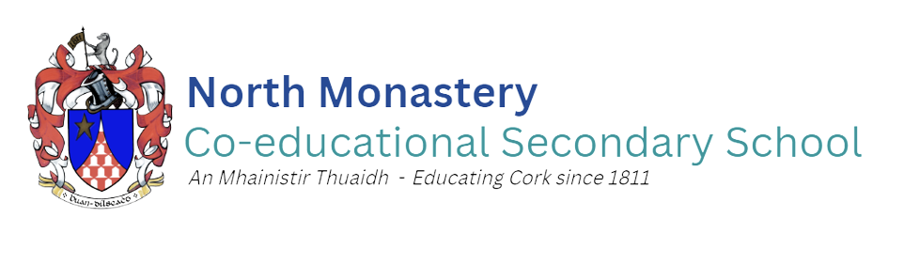
Acting Principal: Dr. Jim Boyle Deputy Principal: Mr. Jason Barry
Phone: 021-4301318 E-mail: info@northmonastery.ie

1st Year Enrolment Form
This is an application form for admission and does not constitute an offer of a place, implied or otherwise.

All Application Forms and accompanying documentation should be sent to: | For office use only
Admissions,  North Monastery Co-educational Secondary School  North Monastery Road  Cork City  T23 P825 | Date received:  ________/_______/________  School Stamp:

Please complete all sections of the following application using BLOCK CAPITALS
SECTION 1 - PROSPECTIVE STUDENT DETAILS
Details of the young person for whom this application is being made.
First Name:
Middle Name:
Surname: |  |  |  |  |  | Date of Birth:
Prospective Student’s Address:
Students PPSN:
Mothers Maiden Name
SECTION 2 – DETAILS OF PARENT/GUARDIAN
This information is sought for the purposes of making contact about this application. If more than one name is given but the address is the same, only one letter will issue and will be addressed to both individuals.
 | Parent / Guardian 1 |  |  |  |  |  | Parent / Guardian 2
Prefix: (e.g. Mr. / Ms. / Ms. etc.)
First Name:
Surname:
Address:
Eircode:
Telephone no.
Email address:
Relationship to prospective student:

SECTION 3 – STUDENT CODE OF BEHAVIOUR
Please confirm that the Student Code of Behaviour is acceptable to you as a parent/guardian and that you shall make all reasonable efforts to ensure compliance of same by the prospective student if he secures a place in the school. Please note that the Code of Behaviour can be found at www.northmonastery.ie or obtained from the school office.
I _______________________________________ confirm that the Code of Behaviour for the school is acceptable to me as the prospective student’s parent/guardian and I shall make all reasonable efforts to ensure compliance by the prospective student if he secures a place in the school.

SECTION 4 –PROSPECTIVE STUDENT’S GENDER

Please confirm the prospective student’s gender or gender identity for the purpose of determining eligibility in line with the school’s Admission Policy.
Male Female

SECTION 5 – SPECIAL CLASS

The special class in North Monastery Secondary Co-educational Secondary School teaches students who have one or more of the following special educational needs: Autism Spectrum Disorder
Please ONLY complete if you are applying for the special class.
Please confirm if this application is being made for:
The special class only: OR The special class or the mainstream year group:

Where the prospective student is seeking a place in the special class, please provide details of the special educational needs of the prospective student, including an Educational/Clinical Psychologist’s report.

- STUDENTS CURRENT SCHOOL – PLEASE GIVE DETAILS.
School name:
Address
Current class
Teacher Name
85SECTION 6 – SELECTION CRITERIA FOR ADMISSION IN THE EVENT OF OVERSUBSCRIPTION
This information will assist in determining whether the prospective student meets the admission requirements in accordance with the order of priority as set out in section 6 of the Admission Policy for North Monastery Co-educational Secondary School

Please confirm the prospective student’s address for the purpose of determining where she/he resides. Please note that recent proof of address will be required in support of this. (Only registered utility bills or bank statements dated within the last three months and in the name of the parent(s)/guardian(s) will be accepted.)
Address:

A; If the prospective student currently has any siblings in this school, please indicate their name(s) and current year(s) of study.
- Name:
Year:
- Name:
Year:
- Name:
Year:
- Name:
Year:

- If the prospective student has previously had any sibling(s) in this school, please indicate their name(s) and years of attendance
- Name:
Years:
- Name:
Years:

- If the prospective student’s parent(s) or grandparent(s) previously attended this school, please indicate their name(s) and years of attendance
- Name:
Year(s):
- Name:
Year(s):

IMPORTANT INFORMATION:
- Please understand that it your responsibility to inform the school of any change in contact information or circumstances relating to this application.
- For information regarding how your data is processed by the school, please see overleaf.
- Please sign below to demonstrate that you have read and understood this information.

(Parent / Guardian 1) (Date)

(Parent / Guardian 2) (Date)
DATA PROTECTION
The board of management of North Monastery Secondary Co-educational Secondary School Cork is a data controller under the General Data Protection Regulations and the Data Protection Acts 1988 - 2018.

The personal data supplied on this Application Form and the accompanying documentation sought is required for the purpose of:
- Verification of identity and date of birth;
- Verification and assessment of admission criteria;
- School administration,
all of which are tasks carried out pursuant to various statutory duties to which the board of management is subject.

Failure to provide the requested information may result in the application being deemed invalid and an offer of a place may not be made.

The personal data disclosed in this Application Form may be communicated internally within the school for the purpose of determining the applicability of the selection criteria and possibly with the patron or board of management of other schools in order to facilitate the efficient admission of students, pursuant to section 66(6) of the Education Act 1998 as inserted by section 9 of the (Admissions to Schools) Act 2018.

The personal data provided in this Application Form will be kept for 7 years from the date on which the student turns 18 years of age, unless there is a statutory requirement to retain some or all elements of the data for a further period or indefinitely. I

Any person who provides personal data through this Application Form has a right to request access to that data. S/he also has a right to request the changing of any information if it is factually incorrect. A request for erasure of the data can also be made by or on behalf of the data subject but this will only be acceded to where the data is no longer necessary for the purpose for which it was collected and where the board of management does not have a legal basis for retaining it.

If you as a data subject have any complaints regarding the processing of your personal data, you have the right to lodge a complaint with the Data Protection Commission.

